 | Maroubra Seals Snooker  Organiser cheat sheet — running a competition night

Everything happens on one page: Tonight (the bracket). You start each match, record each result, and the app moves winners up the draw by itself. Nothing is a one-way door: a wrong tap can be undone.
The night in five taps. Log in → Start Competition → Start each match (pick a table) → Record result (winner + buy-back) → Close entries when no one else is coming. Keep going until the Final is done.

1. Log in
- Open the site on the club computer and go to /admin/login (or tap Organiser Login at the top of the public page).
- Type your admin code and press Log in. The code is your identity: the app records your name against every change you make.
- You land on Tonight if a competition is running, or on Setup if it is not.
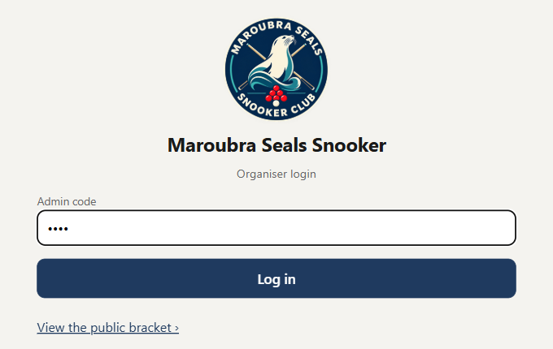
The login page. One box, one button.
"Code not accepted" means a typo or an old code. Nothing has changed, just try again. Your device stays logged in from week to week; Admin ▾ → Log out (top right) signs you out.

2. Set up the night
Two decisions: bracket size and who is playing. Everything else is already set.
- Check the Name (defaults to tonight's date) and pick the Bracket size: 16 or 32.
- Tick the players who are here in Club players, then tap Add ›. Use the search box for a long list. + New player adds someone not on the club list.
- Read the summary line ("10 players → 5 matches, 6 open slots for buy-backs") and tap Start Competition, then Start the night on the confirmation.
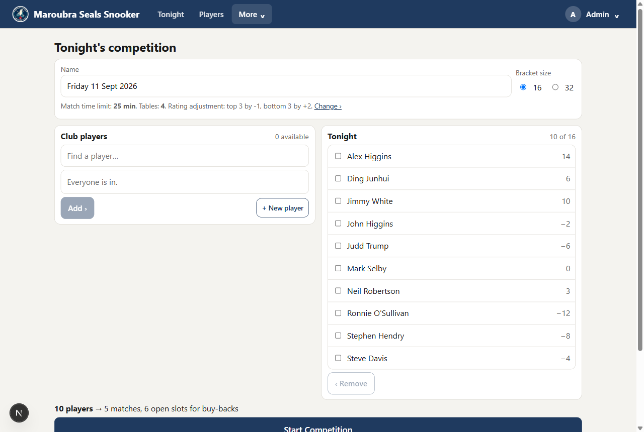
Setup: club players on the left, tonight's players on the right, Start Competition at the bottom.
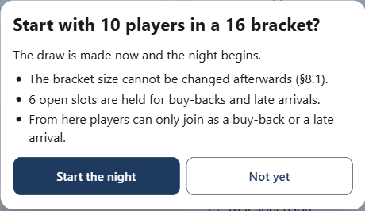
The confirmation tells you what is locked from here.
Locked after Start: the bracket size. Players can still join as a late entry or a buy-back while entries are open. The draw is random; nobody picks their spot.

3. Start a match
The Tonight page shows the whole draw as a tree. Every match with two players has a ▶ Start button on its box.
- Tap ▶ Start on the match that is going to a table.
- Tap the free table it is playing on. That tap starts the clock.
- The box turns green with a LIVE chip, the table strip shows the match, and the 25-minute countdown runs on the server, so it survives a refresh or a locked screen.
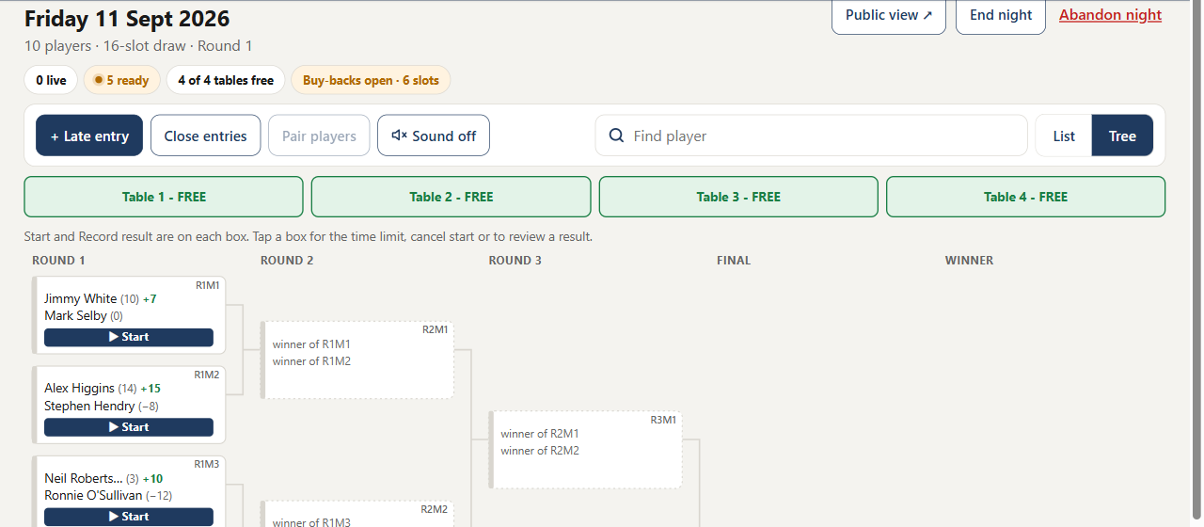
Round one drawn. Start is on every ready match; the strip shows all four tables free.
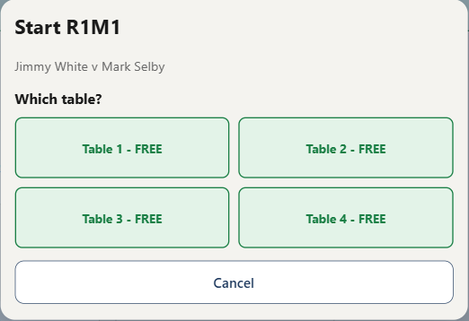
Start asks which table. Busy tables are greyed out.
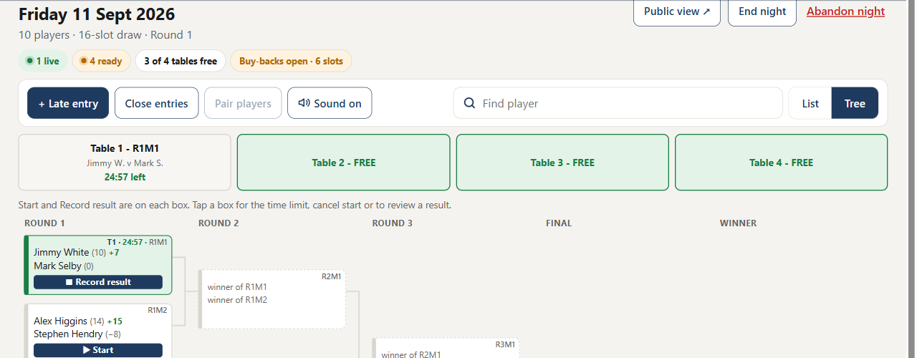
R1M1 live on Table 1: the chip in the header counts live matches, the strip shows the clock.
Handicap start. The number beside a name is the player's rating (lower is better). The green +7 is the start: the weaker player (higher number) starts on two thirds of the difference. The card spells it out: "Jimmy White starts on 7 (⅔ of 10)".
Started the wrong match? Tap the box, then ⤺ Cancel start. The match goes back to ready and the clock is cleared. At zero the app says "Match timed out" aloud and shows a warning, but the match stays live until you record the result.

4. Record the result and the buy-back
- When the frame ends, tap ■ Record result on the live box (or tap the box and then Record result).  - Under Who won? tap the winner.  - Under Buy-back decision tap what the loser chose: buys back · $2 or declines. This only appears for a round-one loser who has not bought back yet; from round two a loser is simply out.  - Check the summary line, then tap Save result. | 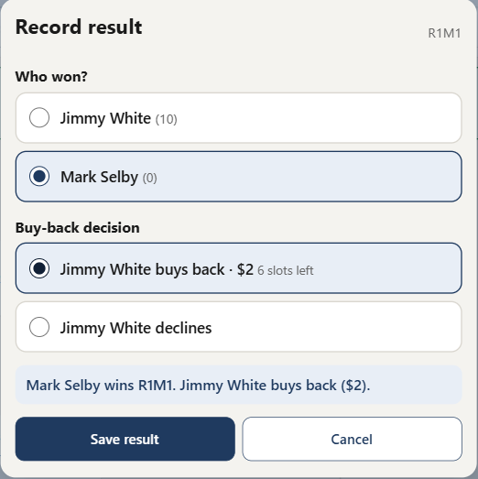  Record result: winner, then the loser's buy-back. Save stays greyed until both are chosen.

After Save the note at the top says where everyone went: the winner moves up the tree at once, and a buy-back goes straight into a random open slot in round one.
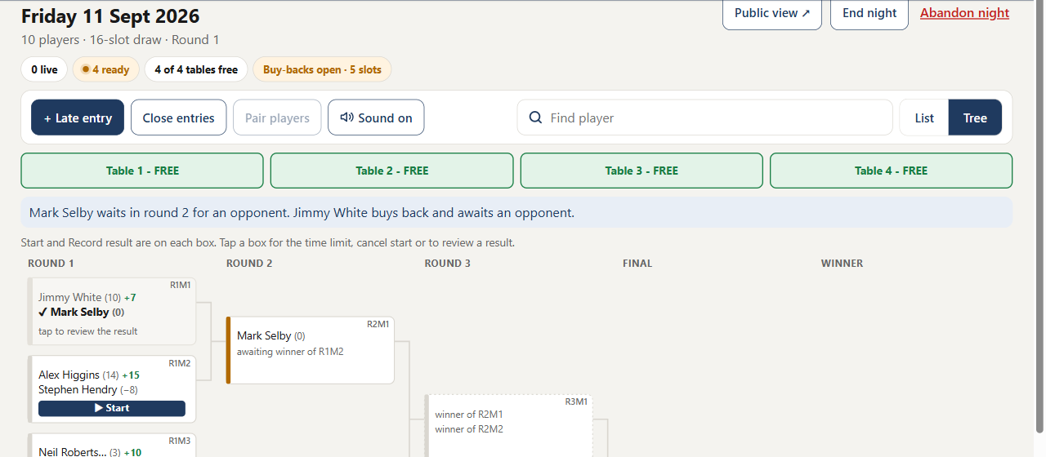
Mark Selby moved to R2M1 and waits for the R1M2 winner. Jimmy White bought back and waits for an opponent.
Slots are first come, first served. Each buy-back uses one open slot. The count is shown next to the option; when none are left the buy-back is greyed out and the loser is out, even if they wanted to pay.
Wrong result? Tap the finished box, then Review result. You can change it until the winner's next match has started. After that, use Master override (section 7).

5. Close entries (no more buy-backs)
Entries never close by themselves. When nobody else is coming and round-one losers are done buying back, close the window. Do it once, late enough that every buy-back has been offered.
- Tap Close entries in the toolbar on the Tonight page.
- Read the card. It names every player still alone in round one; each of them gets a free pass straight to round two.
- Tap Close the window.
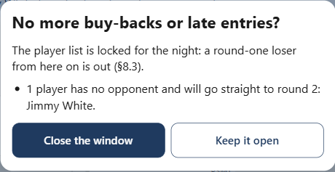
The confirmation names who gets a free pass.
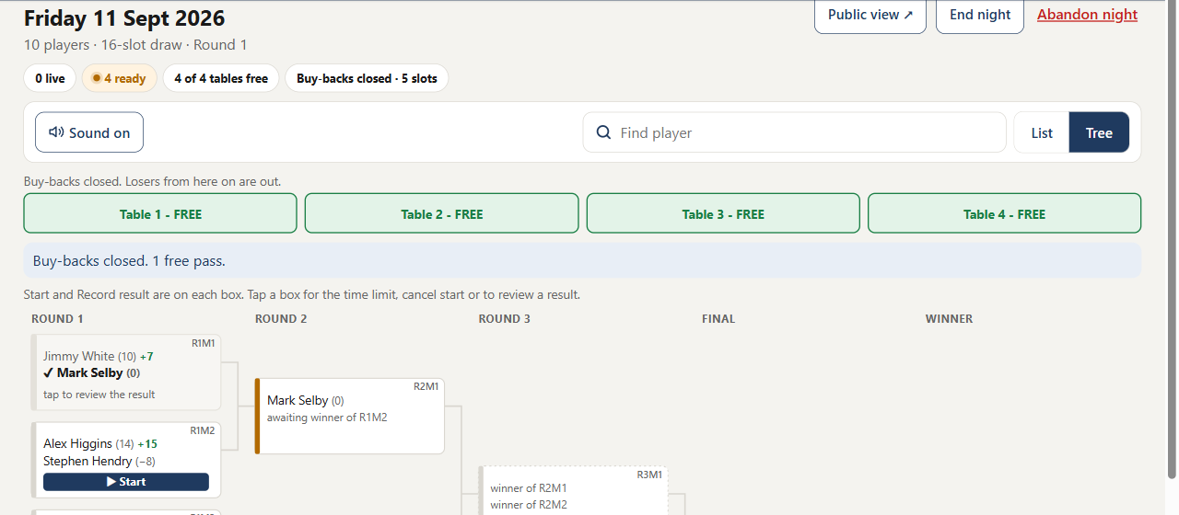
Entries closed: the toolbar loses Late entry, Close entries and Pair players. The header reads "Buy-backs closed".
After closing: a round-one loser is out, late entries are refused, lone players climb by free pass until they meet an opponent. Closed by mistake? More ▾ → Override → Reopen buy-backs.

6. Finishing the night
- Keep starting and recording matches. Winners climb automatically; a box waiting for the other side shows AWAITING OPPONENT .
- When the Final result is saved the night is complete and the app opens the Ratings review by itself. Every player's new handicap is proposed from tonight's finishing order; change any box, then tap Save rating changes. That lands you on the night in History.
- Out of time? End night (top right) closes the night with no winner. It shows what is unplayed before you confirm and cannot be undone.
- Abandon night (red, top right) scraps the whole night and returns to Setup. Played matches count for nothing.

7. Everything else on the admin side

Where things are
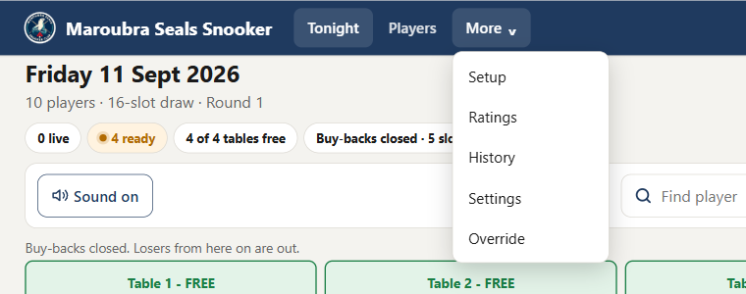
The top bar: Tonight, Players, and the More menu. Admin ▾ on the right has Log out.
Menu | What it is for
Tonight | The bracket and every match control. This is the page for the night.
Players | The club list and ratings. Add, edit, deactivate.
More ▸ Setup | Tonight's competition setup. Only reachable while no night is running.
More ▸ Ratings | End-of-night handicap review. Opens by itself when the night completes.
More ▸ History | Past nights: bracket, winner, rating changes, and a handicap grid across nights.
More ▸ Settings | Time limit, number of tables, rating adjustment scale.
More ▸ Override | Master override: the escape hatch when the normal buttons refuse.
Admin ▾ ▸ Log out | Signs this device out.

Tonight page toolbar
Control | What it does
+ Late entry | Adds a player who turned up after the draw. Club list, or tick "New player" for someone new. Takes one open slot. Gone once entries are closed.
Close entries | Ends buy-backs and late entries for the night (section 5).
Pair players | Pairs two waiting round-one players at random so they can play now instead of waiting for a buy-back. Needs two waiting players; greyed otherwise.
Sound on / off | The spoken "Match timed out" alert when a clock hits zero.
Find player | Type a name to see where that player is: playing, waiting, or out.
List | Tree | Two views of the same draw. Tree shows the whole bracket; List shows cards by round, newest round first. Your choice is remembered on this device.
Table strip | Every table, free (green) or with its match and clock.
Public view ↗ | Opens the read-only page everyone else watches.
End night | Closes an unfinished night with no winner (section 6).
Abandon night | Scraps the night and returns to Setup (section 6).

On a match box (tap the box)
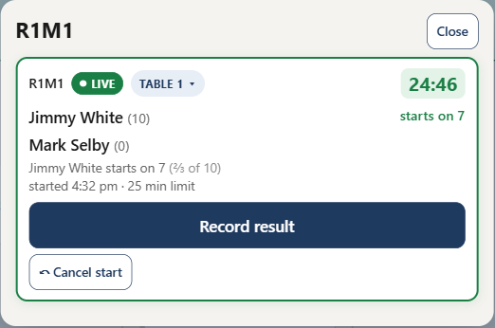
The match card. Record result is full width; the rarer taps are small.
Control | What it does
Table ▾ chip | Moves a live match to another free table, or pre-notes the table for a ready match.
25 min limit | On a ready match, tap the limit to change it for this match only.
⤺ Cancel start | Un-starts a live match. Clock and table cleared, nothing else touched.
Review result | Changes a saved result while the winner's next match has not started.

Players & ratings
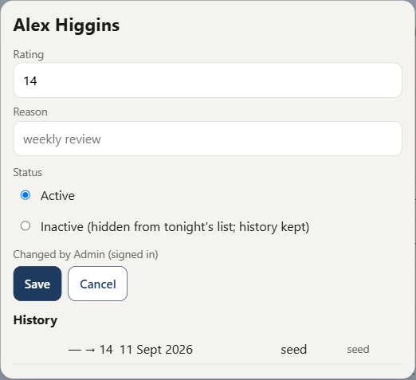
Edit a player: rating, reason, active or inactive, and the change history.
Action | Notes
+ Add player | Name and starting rating. Ratings run from −100 to 200; lower is better, negative is normal for strong players.
Edit ▸ Save | Overrides the rating. Logged with your name, the time and the reason. Never changes a match already drawn tonight.
Inactive | Hides a player from the entry list and the public page. Nothing is ever deleted; history is kept. A player in tonight's draw cannot be made inactive until the night ends.
Show inactive | Tick to see and reactivate hidden players.

Settings
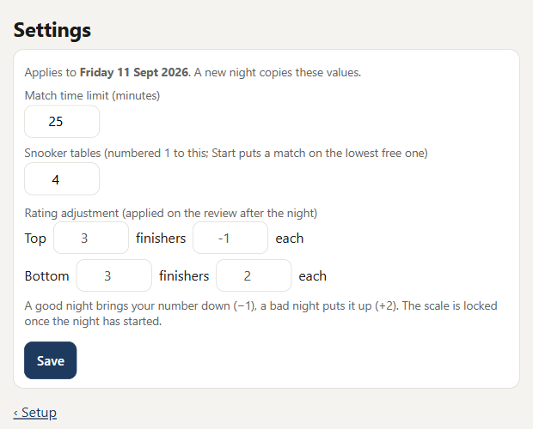
Settings apply to the current night and carry over to the next one.
Setting | Notes
Match time limit | Default 25 minutes. Can change during the night; affects matches not yet started.
Snooker tables | How many tables tonight (default 4). Cannot drop below a table with a live match.
Rating adjustment | Top X finishers by Y, bottom Z by W (default top 3 by −1, bottom 3 by +2). Drives the proposed ratings in the end-of-night review. Locked once the night has started.

Master override
Use it when a normal button refuses and you know what you want. Every action asks for confirmation, names the consequences, and is logged with your name under Recent overrides.
Action | What it does
Add a player to the night | Enters anyone at any point, even after entries are closed or the bracket is full (it grows 16 → 32 first).
Remove | Takes a player out. Their unstarted matches are deleted; a finished match they won is voided back to the last round not yet started.
Reset | Puts a match back to not started, clears the result and clock, and pulls the winner out of the next round.
Delete | Removes a match; both players go back to waiting.
Pair two waiting players | Creates a match between any two chosen waiting players, no randomness.
Grant / Revoke free pass | Moves a player to the next round without playing, or takes it back.
Reopen buy-backs | Undoes Close entries.
Grow bracket 16 → 32 | Adds slots 17 to 32 as open slots. Cannot shrink.
Abandon this competition | Same as Abandon night.

History
Comp history shows each past night: the bracket as played, winner and runner-up, and the rating changes saved in its review. Handicap history is a grid of every player against every night, with the rating they left each night on. Nothing here changes anything.

The public page (phones)
Everyone else watches the site's front page on their own phone. No login, nothing to tap that changes anything, and it refreshes every 10 seconds.  Three tabs along the bottom:  - Tonight: find my match, the tables, playing now, up next, results.  - Draw: the full bracket, list or tree.  - Players: the club list with handicaps.  Share the link or a QR code; the Public view ↗ button on the Tonight page opens it. | 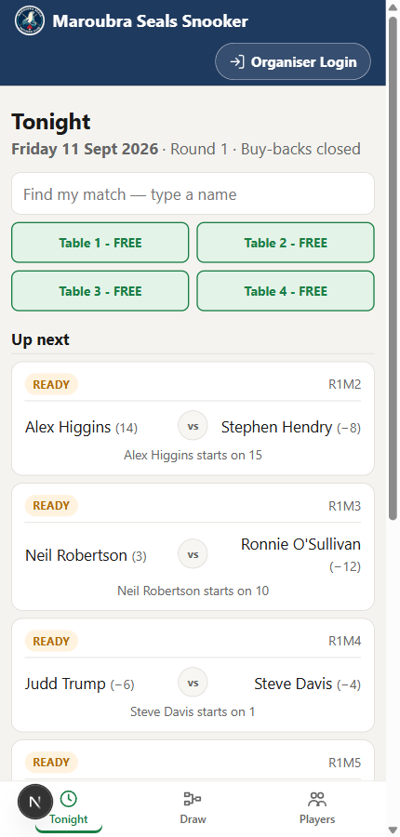  The public Tonight tab on a phone.

